International Economics: Theory and Policy, 12e (Krugman)
Chapter 16 Price Levels and the Exchange Rate in the Long Run

16.1 The Law of One Price

1) Which of the following statements is the MOST accurate?
A) In the long run, national price levels play a minor role in determining both interest rates and the relative prices at which countries' products are traded.
B) In the long run, national price levels play a key role only in determining interest rates.
C) In the long run, national price levels play a key role only in determining the relative prices at which countries' products are traded.
D) In the long run, national price levels play a key role in determining both interest rates and the relative prices at which countries' products are traded.
E) In the long run, national price levels play no role in determining interest rates and the relative prices at which countries' products are traded.
Answer: D
Difficulty: Easy
AACSB: Application of knowledge

2) Which of the following statements is the MOST accurate? The law of one price states
A) in competitive markets free of transportation costs and official barriers to trade, identical goods sold in different countries must sell for the same price when their prices are expressed in terms of the same currency.
B) in competitive markets free of transportation costs and official barriers to trade, identical goods sold in the same country must sell for the same price when their prices are expressed in terms of the same currency.
C) in competitive markets free of transportation costs and official barriers to trade, identical goods sold in different countries must sell for the same price.
D) identical goods sold in different countries must sell for the same price when their prices are expressed in terms of the same currency.
E) in competitive markets free of official barriers to trade, identical goods are sold at the same price regardless of transportation costs.
Answer: A
Difficulty: Easy
AACSB: Application of knowledge

3) The law of one price states that when trade is open and costless, identical goods must trade at ________ prices regardless of where they are sold.
A) the same relative
B) higher
C) lower
D) different
Answer: A
Difficulty: Easy
AACSB: Application of knowledge

4) Using the law of one price, if the dollar/pound exchange rate is $1.50 per pound and a sweater sells for $45 in New York must sell for ________ per sweater in London, the same as its price in New York.
A) ₤30.00
B) ₤45.00
C) ₤67.50
D) ₤15.00
Answer: A
Difficulty: Easy
AACSB: Application of knowledge

5) Using the law of one price, if the dollar/euro exchange rate is $1.25 per euro, a Tesla Model 3 car sells for $35,000 in the U.S. market must sell for ________ in Europe.
A) ₤28,000
B) ₤43,750
C) ₤35,714
D) ₤52,490
E) ₤54,990
Answer: A
Difficulty: Easy
AACSB: Application of knowledge

6) Under the law of one price, if the price for one particular good is PUS in the US and PE in Europe, then
A) E$/P = PUS/PE.
B) E$/€ = PUS/PE
C) E$/€ = PUS - PE.
D) E$/€ = PE/PES.
E) E$/€ = PUS + PE.
Answer: B
Difficulty: Easy
AACSB: Application of knowledge

7) Explain the Law of One Price. Give an example.
Answer: The law of one price states that in competitive markets free of transportation costs and trade barriers, identical goods sold in different countries must sell for the same price when expressed in terms of the same currency.
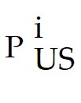 = (E$/£) × (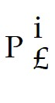) for good i.
E$/£ = /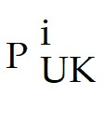
If, for example, the price of the same sweater was cheaper in London than in New York, U.S. importers and British exporters would have an incentive to buy sweaters in London and ship them to New York, pushing the London price up and the New York price down, until both were equal.
Difficulty: Moderate
AACSB: Application of knowledge

8) Fill in the following table, assuming the law of one price prevails.

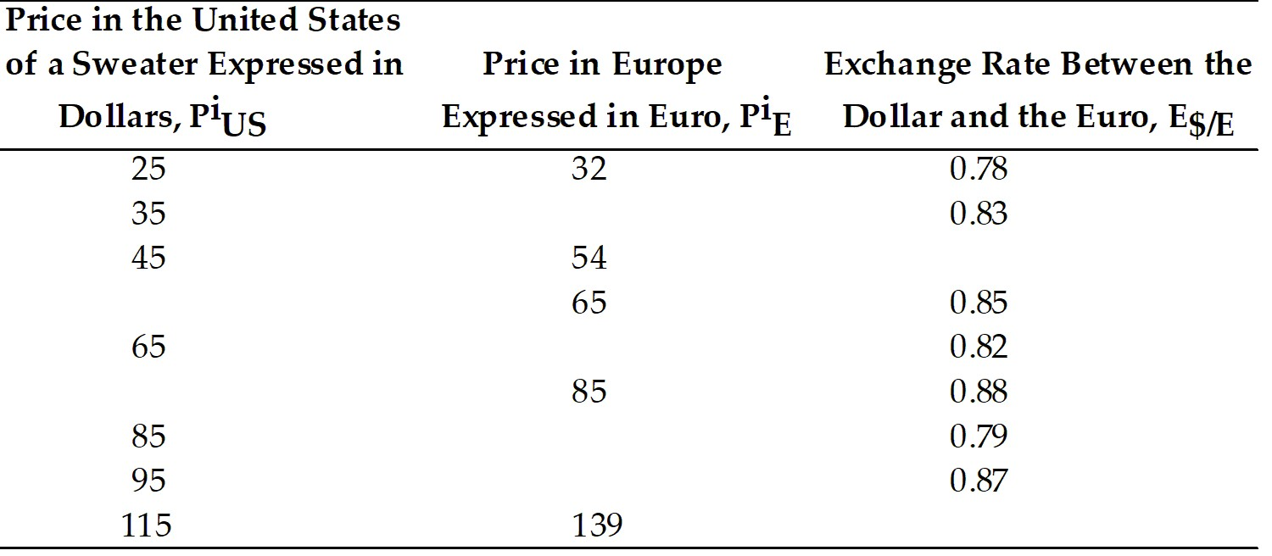

Answer:
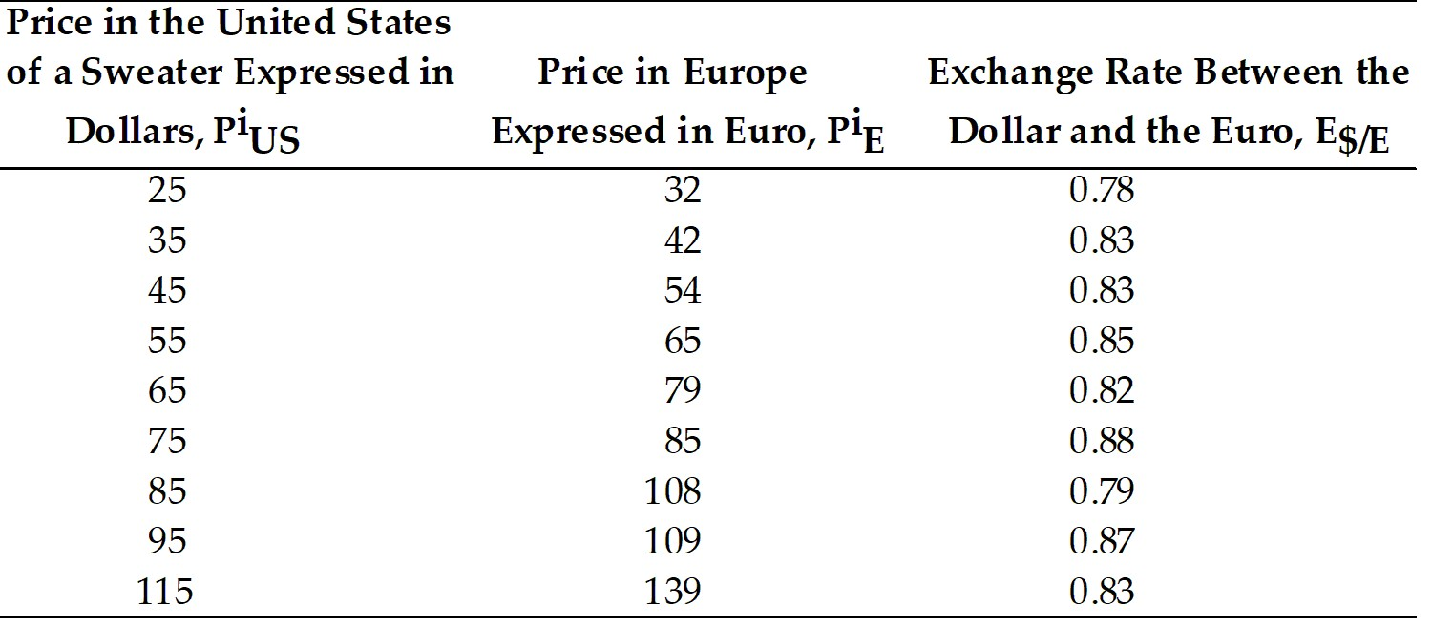

Difficulty: Moderate
AACSB: Analytical thinking

16.2 Purchasing Power Parity

1) The theory of purchasing power parity states that the exchange rate between two countries' currencies ________ the ratio of the countries' price levels.
A) equals
B) is higher than
C) is lower than
D) is different from
Answer: A
Difficulty: Easy
AACSB: Application of knowledge

2) The purchasing power parity theory predicts that a ________ in a currency's domestic purchasing power will be associated with a proportional currency ________ in the foreign exchange market.
A) fall; depreciation
B) fall; appreciation
C) rise; depreciation
D) rise; floating
Answer: A
Difficulty: Easy
AACSB: Application of knowledge

3) Under Purchasing Power Parity
A) E$/€ = PiUS/PiE.
B) E$/€ = PiE/PiUS.
C) E$/€ = PUS/PE.
D) E$/€ = PE/PES.
E) E$/€ = PiE + PiUS/PiE.
Answer: C
Difficulty: Easy
AACSB: Application of knowledge

4) If the reference commodity basket costs $200 in the United States and €160 in Europe, Purchasing Power Parity (PPP) theory predicts a dollar/euro exchange rate of ________ per euro. If the U.S. price level were to triple to $600/basket, PPP would imply an exchange rate of ________ per euro.
A) $1.25; $3.75
B) $1.25; $0.42
C) $0.80; $2.40
D) $0.80; $0.27
Answer: A
Difficulty: Easy
AACSB: Application of knowledge

5) Which of the following statements is the MOST accurate?
A) The law of one price applies only to the general price level.
B) The law of one price applies to the general price level while PPP applies to individual commodities.
C) The law of one price applies to individual commodities while PPP applies to both the general price level and to individual commodities.
D) PPP applies only to individual commodities.
E) The law of one price applies to individual commodities while PPP applies to the general price level.
Answer: E
Difficulty: Easy
AACSB: Application of knowledge

6) Which of the following statements is the MOST accurate?
A) If PPP holds true, then the law of one price holds true for every commodity as long as the reference baskets used to reckon different countries' price levels are the same.
B) If the law of one price holds true for every commodity, PPP must hold automatically.
C) If the law of one price holds true for every commodity, PPP must automatically hold as long as the reference baskets used to reckon different countries' price levels are the same.
D) If the law of one price does not hold true for every commodity, PPP cannot be true as long as the reference baskets used to reckon different countries' price levels are the same.
E) If PPP holds true, then the law of one price must hold true automatically.
Answer: C
Difficulty: Easy
AACSB: Application of knowledge

7) Which of the following statements is the MOST accurate?
A) Absolute PPP does not imply relative PPP.
B) Relative PPP implies absolute PPP.
C) There is no causality relation between the two.
D) Absolute PPP implies relative PPP.
E) Absolute PPP is inversely related to relative PPP.
Answer: D
Difficulty: Easy
AACSB: Application of knowledge

8) Which of the following statements is the MOST accurate?
A) Relative PPP may be valid even when absolute PPP is not, provided the factors causing deviations from absolute PPP are more or less stable over different commodities space.
B) Absolute PPP may be valid even when relative PPP is not, provided the factors causing deviations from relative PPP are more or less stable over time.
C) Relative PPP may be valid even when absolute PPP is not, provided the factors causing deviations from absolute PPP are more or less stable over time.
D) Relative PPP is not valid when absolute PPP is not.
E) Relative PPP is only valid when absolute PPP is valid, providing the factors causing deviations from relative PPP are more or less stable over time.
Answer: C
Difficulty: Moderate
AACSB: Application of knowledge

9) Explain Purchasing Power Parity.
Answer: PPP states that the exchange rate between two countries' currencies equals the ratio of the countries' price levels.
A fall in a currency's domestic purchasing power (i.e. an increase in the domestic price level) will be associated with a proportional currency depreciation in the foreign exchange market and vice versa.
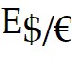 = PUS/PE where P is the price of a reference commodity basket.
Rearrange: PUS =  × (PE)
Thus, PPP asserts that all countries' price levels are equal when measured in terms of the same currency.
Difficulty: Moderate
AACSB: Application of knowledge

10) Discuss the relationship between PPP and the Law of One Price.
Answer: The law of one price applies to individual commodities while PPP applies to the general price level.
Proponents of PPP argue that its validity in the long run doesn't require the law of one price to hold exactly. When goods and services temporarily become more expensive in one country than in others, the demands for its currency and its products falls, pushing the exchange rate and domestic prices back in line with PPP and vice versa.
Difficulty: Moderate
AACSB: Application of knowledge

11) Discuss the differences between Absolute PPP and Relative PPP.
Answer: Absolute PPP states that the exchange rate between two currencies equals the ratio of their price levels. Relative PPP states that the percentage change in the exchange rate between two currencies over a given period equals the difference between the inflation rates of those two currencies.
Difficulty: Moderate
AACSB: Application of knowledge

12) Explain why Relative PPP is useful when comparing countries that base their price levels on different product baskets.
Answer: For Example: If the U.S. price level rises by 10% over a year while Europe's rises by only 5%, relative PPP predicts a 5% depreciation of the dollar against the euro. This just cancels the 5% by which U.S. inflation exceeds European, leaving the relative domestic and foreign purchasing powers of both currencies unchanged.
(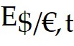 - 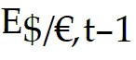)/ = (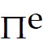)US,t - ()E,t between dates t and t - 1.
Relative PPP is useful when comparing countries that base their price levels on different product baskets. Relative PPP may be valid even when absolute PPP is not.
Difficulty: Moderate
AACSB: Application of knowledge

13) Suppose Russia's inflation rate is 200% over one year but the inflation rate in Switzerland is only 2%. According to relative PPP, what should happen over the year to the Swiss franc's exchange rate against the Russian ruble?
Answer: (Eruble/franc, t - Eruble/franc, t-1)/Eruble/franc, t-1 = 2 - 0.02 = 1.98
So there will be a 198% depreciation of the ruble against the franc or, conversely, a 198% appreciation of the franc against the ruble.
Difficulty: Moderate
AACSB: Application of knowledge

14) Assuming relative PPP, fill in the table below:

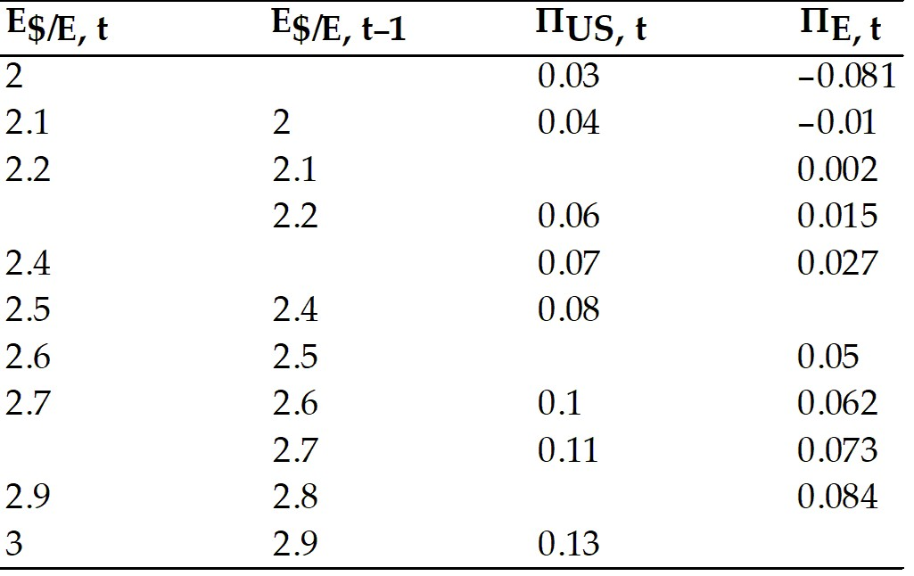

Answer: Using (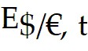 - 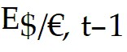)/ = ΠUS, t - ΠE, t one gets:

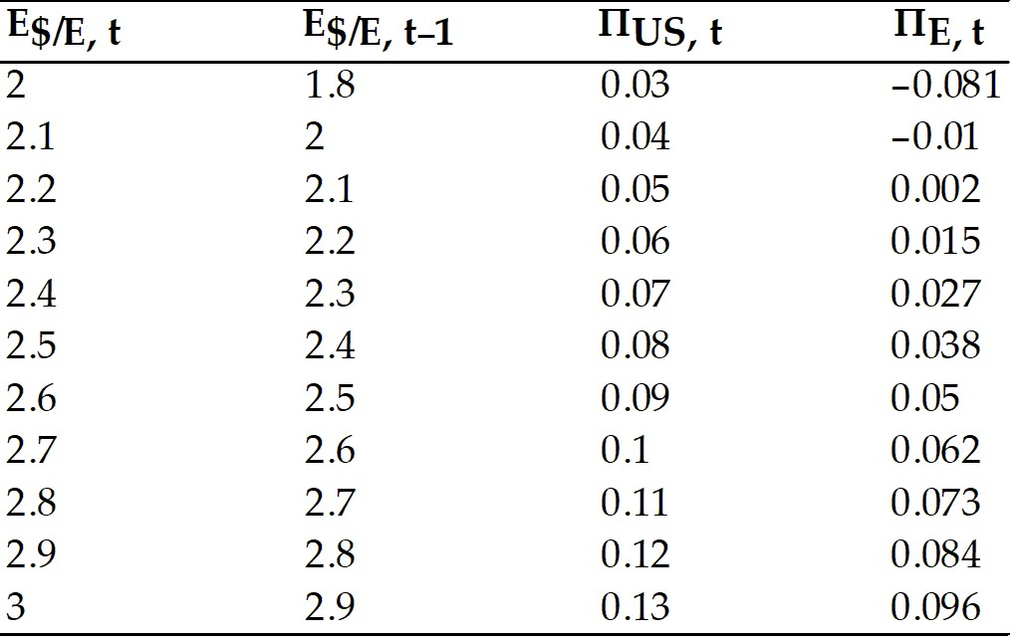
Difficulty: Moderate
AACSB: Analytical thinking

16.3 A Long-Run Exchange Rate Model Based on PPP

1) Which of the following statements is the MOST accurate? In general
A) the monetary approach to the exchange rate is a long run theory.
B) the monetary approach to the exchange rate is a short run theory.
C) the monetary approach to the exchange rate is both a short and long run theory.
D) the monetary approach to the exchange rate neither long run nor short run theory.
E) the monetary approach to the exchange rate is considered less practical than the law of one price.
Answer: A
Difficulty: Easy
AACSB: Application of knowledge

2) The monetary approach makes the general prediction that
A) the exchange rate, which is the relative price of American and European money, is fully determined in the long run by the relative supplies of those monies.
B) the exchange rate, which is the relative price of American and European money, is fully determined in the short run by the relative supplies of those monies and the relative demands for them.
C) the exchange rate, which is the relative price of American and European money, is fully determined in the short run and long run by the relative supplies of those monies and the relative demands for them.
D) the exchange rate, which is the relative price of American and European money, is fully determined in the long run by the relative supplies of those monies and the relative demands for them.
E) the money supply in the U.S. will adjust to European monetary equilibrium.
Answer: D
Difficulty: Easy
AACSB: Application of knowledge

3) Under the monetary approach to exchange rate theory, money supply growth at a constant rate
A) eventually results in ongoing price level deflation at the same rate, but changes in this long-run deflation rate do not affect the full-employment output level or the long-run relative prices of goods and services.
B) eventually results in ongoing price level inflation at the same rate, but changes in this long-run inflation rate do affect the full-employment output level and the long-run relative prices of goods and services.
C) eventually results in ongoing price level inflation at the same rate, but changes in this long-run inflation rate do not affect the full-employment output level or the long-run relative prices of goods and services.
D) eventually results in ongoing price level inflation at the same rate, but changes in this long-run inflation rate do not affect the full-employment output level, only the long-run relative prices of goods and services.
E) eventually results in ongoing price level deflation at the same rate, but changes in this long-run deflation rate do not affect the full-employment output level, only the long-run relative prices of goods and services.
Answer: C
Difficulty: Easy
AACSB: Application of knowledge

4) Which of the following statements is the MOST accurate? In general, under the monetary approach to the exchange rate
A) the interest rate is not independent of the money supply growth rate in the short run.
B) the interest rate is independent of the money supply growth rate in the long run.
C) the interest rate is not independent of the money supply growth rate in the long run, but independent in the short run.
D) the interest rate is not independent of the money supply growth rate in the long run.
E) the interest rate is a factor of the money supply growth rate only in the short term.
Answer: D
Difficulty: Easy
AACSB: Application of knowledge

5) Which of the following statements is the MOST accurate? In general, under the monetary approach to the exchange rate
A) while the short-run interest rate does not depend on the absolute level of the money supply, continuing growth in the money supply eventually will affect the interest rate.
B) while the long-run interest rate does depend on the absolute level of the money supply, continuing growth in the money supply does not affect the interest rate.
C) while the long-run interest rate does not depend on the absolute level of the money supply, continuing growth in the money supply eventually will affect the interest rate.
D) the long-run interest rate does not depend on the absolute level of the money supply, and thus continuing growth in the money supply will not affect the interest rate.
E) while the short-run interest rate does not depend on the absolute level of the money supply, continuing decline in the money supply eventually will not affect the interest rate.
Answer: C
Difficulty: Easy
AACSB: Application of knowledge
6) If people expect relative PPP to hold
A) the difference between the interest rates offered by dollar and euro deposits will equal the difference between the inflation rates expected, in the United States and Europe, respectively, over the relevant horizon.
B) the difference between the interest rates offered by dollar and euro deposits will equal the difference between the inflation rates expected in Europe and the United States, respectively.
C) the difference between the interest rates offered by dollar and euro deposits will equal the difference between the inflation rates expected, over the relevant horizon, in the United States and Europe, respectively, in the short run.
D) the difference between the interest rates offered by dollar and euro deposits will be above the difference between the inflation rates expected, over the relevant horizon, in the United States and Europe, respectively.
E) the difference between the interest rates offered by dollar and euro deposits will be below the difference between the inflation rates expected, over the relevant horizon, in the United States and Europe, respectively.
Answer: A
Difficulty: Moderate
AACSB: Application of knowledge

7) Who among the following list of people is an early 20th century economist from Yale University who wrote the book The Theory of Interest?
A) Gustav Cassel
B) Irving Fisher
C) David Ricardo
D) Paul Krugman
E) Israel Kirzner
Answer: B
Difficulty: Easy
AACSB: Application of knowledge

8) Under PPP (and by the Fisher Effect), all else equal
A) a rise in a country's expected inflation rate will eventually cause a more-than proportional rise in the interest rate that deposits of its currency offer in order to accommodate for the higher inflation.
B) a fall in a country's expected inflation rate will eventually cause an equal rise in the interest rate that deposits of its currency offer.
C) a rise in a country's expected inflation rate will eventually cause an equal rise in the interest rate that deposits of its currency offer.
D) a rise in a country's expected inflation rate will eventually cause a less than proportional rise in the interest rate that deposits of its currency offer to accommodate the rise in expected inflation.
E) a fall in a country's expected inflation rate will eventually cause an inversely proportional rise in the interest rate that deposits of its currency offer to accommodate the rise in expected inflation.
Answer: C
Difficulty: Easy
AACSB: Application of knowledge
9) In the short run
A) the interest rate can rise when the domestic money supply falls.
B) the interest rate can decrease when the domestic money supply falls.
C) the interest rate stays constant when the domestic money supply falls.
D) the interest rate rises in the same proportion as the domestic money supply falls.
E) the interest rate never rises when the domestic money supply falls.
Answer: A
Difficulty: Easy
AACSB: Application of knowledge

10) Under a flexible-price monetary approach to the exchange rate
A) when the domestic money supply falls, the price level would eventually fall, increasing the interest rate.
B) when the domestic money supply falls, the price level would fall right away, causing a reduction in the interest rate.
C) when the domestic money supply falls, the price level would fall right away, causing an increase in the interest rate.
D) when the domestic money supply falls, the price level would eventually fall, keeping the interest rate constant.
E) when the domestic money supply falls, the price level would fall right away, keeping the interest rate constant.
Answer: E
Difficulty: Easy
AACSB: Application of knowledge

11) Under sticky prices
A) a fall in the money supply raises the interest rate to preserve money market equilibrium.
B) a fall in the money supply reduces the interest rate to preserve money market equilibrium.
C) a fall in the money supply keeps the interest rate intact to preserve money market equilibrium.
D) a fall in the money supply does not affect the interest rate in the short run, only in the long run.
E) a fall in the money supply raises the interest rate to preserve money market equilibrium in the long run.
Answer: A
Difficulty: Easy
AACSB: Application of knowledge

12) Under sticky prices
A) an interest rate rise is associated with lower expected deflation and a long-run currency appreciation, so the currency appreciates immediately.
B) an interest rate rise is associated with higher expected inflation and a long-run currency appreciation, so the currency appreciates immediately.
C) an interest rate rise is associated with lower expected inflation and a long-run currency depreciation, so the currency appreciates immediately.
D) an interest rate rise is associated with lower expected inflation and a long-run currency depreciation, so the currency depreciates immediately.
E) an interest rate rise is associated with lower expected inflation and a long-run currency appreciation, so the currency appreciates immediately.
Answer: E
Difficulty: Easy
AACSB: Application of knowledge

13) Under the monetary approach to the exchange rate
A) an interest rate decrease is associated with higher expected inflation and a currency that will be weaker on all future dates.
B) an interest rate increase is associated with higher expected deflation and a currency that will be weaker on all future dates.
C) an interest rate increase is associated with higher expected inflation and a currency that will be strengthened on all future dates.
D) an interest rate increase is associated with higher expected deflation and a currency that will be strengthened on all future dates.
E) an interest rate increase is associated with higher expected inflation and a currency that will be weaker on all future dates.
Answer: E
Difficulty: Moderate
AACSB: Application of knowledge

14) Under the monetary approach to the exchange rate
A) a reduction in the money supply will cause immediate currency depreciation.
B) a rise in the money supply will cause currency depreciation.
C) a rise in the money supply will cause immediate currency appreciation.
D) a rise in the money supply will cause depreciation.
E) a rise in the money supply will cause immediate currency depreciation.
Answer: E
Difficulty: Moderate
AACSB: Application of knowledge

15) Explain why an exchange rate model based on PPP is a long run theory.
Answer: PPP theory is a monetary approach to the exchange rate. It is a long-run theory because it does not allow for price rigidities. It assumes that prices can adjust right away to maintain full employment as well as PPP.
Difficulty: Moderate
AACSB: Application of knowledge

16) Present and explain the Fundamental Equation of the Monetary Approach.
Answer: Assume  = PUS/PE and that domestic price levels depend on domestic money demands and supplies:
PUS = MUSS/L(R$, YUS)
PE = MES/L(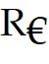, YE)
Therefore, the exchange rate is fully determined in the long run by the relative supplies of those monies and the relative real demands for them. Shifts in interest rates and output levels affect the exchange rate only through their influence on money demand.
Difficulty: Moderate
AACSB: Application of knowledge

17) What are the predictions for the long-run equilibrium of the Monetary Approach?
Answer: Money supplies: Given the equations,
 = PUS/PE
PUS = MUSS/L(R$, YUS)
PE = MES/L(, YE)
one can show that an increase in the U.S. money supply MUSS causes a proportional increase in the U.S. price level PUS, which in turn causes a proportional increase in . Thus, an increase in U.S. money supply causes a proportional long-run depreciation of the dollar against the euro and vice versa.
Interest rates: A rise in the interest rate R$ lowers U.S. money demand L(R$, YUS) thereby causing a rise in the U.S. price level and a proportional depreciation of the dollar against the euro.
Output levels: A rise in U.S. output YUS raises real U.S. money demand leading to a fall in the long-run U.S. price level and an appreciation of the dollar against the euro.
Difficulty: Moderate
AACSB: Application of knowledge

18) Discuss the effects of ongoing inflation based on the PPP theory.
Answer: Other things equal, money supply growth at a constant rate eventually results in ongoing price level inflation at the same rate as the money supply growth, but changes in this long-run inflation rate do not affect the full-employment output level or the long-run relative prices of goods and services.

The interest rate, however, is affected by continuing growth in the money supply (inflation). This can be shown by combining PPP with the interest parity condition. To show it analytically, recall that the condition of parity between dollar and euro assets is:
R$ =  + (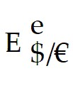 - )/
And according to relative PPP:
( - )/ = ΠUS,t - ΠE,t
If people expect relative PPP to hold, the difference between interest rates offered by dollar and euro deposits will equal the difference between the expected inflation rates, over the relative horizon, in the U.S. and Europe.
Difficulty: Moderate
AACSB: Application of knowledge

19) Describe and explain the relationship between expected inflation rates in two countries and their interest rate differential according to the PPP theory.
Answer: Expected inflation is given by the following equation:
Πe = (Pe - P)/P where Pe is the expected price level in a country a year from today.
If relative PPP is expected to hold then:
( - )/ 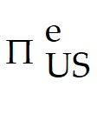 - 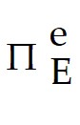
Combine the expected version of relative PPP with the interest parity condition:
R$ =  + ( - )/
Rearrange:
R$ -  = - 
If, as PPP predicts, currency depreciation is expected to offset international inflation difference, the interest rate difference must equal the expected inflation difference.
Difficulty: Difficult
AACSB: Application of knowledge

20) What is the Fisher Effect? Provide an example.
Answer: All else equal, a rise in a country's expected inflation rate will eventually cause an equal rise in the interest rate that deposits of its currency offer. Similarly, a fall in the expected inflation rate will eventually cause a fall in the interest rate.
Ex: If the expected U.S. inflation were to rise permanently from Π to Π + ΔΠ, current dollar interest rates R$ would eventually catch up to the higher inflation, rising by a value ΔR$ = ΔΠ in accordance with the Monetary Approach that in the long run purely monetary developments should have no effect on an economy's relative prices since the real rate of return on dollar assets would remain unchanged.
Difficulty: Moderate
AACSB: Application of knowledge

21) Discuss the different effects on the domestic interest rates when prices are assumed flexible and when they are assumed to be sticky.
Answer: When prices are flexible, a decrease in the domestic money supply has no effect on the interest rate, because of the immediate decrease in the price level. However, when prices are assumed to be sticky, a decrease in the domestic money supply will cause the interest rate to rise, because the sticky domestic price level leads to an excess demand for real money balances at the initial interest rate.
Difficulty: Moderate
AACSB: Application of knowledge

16.4 Empirical Evidence on PPP and the Law of One Price

1) Which of the following statements is the MOST accurate?
A) All versions of the Purchasing Power Parity theory do badly in explaining the actual data on exchange rates and national price levels.
B) Only the absolute Purchasing Power Parity explains well the actual data on exchange rates and national price levels.
C) Only the relative Purchasing Power Parity explains well the actual data on exchange rates and national price levels.
D) All versions of the Purchasing Power Parity theory explain well the actual data on exchange rates and national price levels.
Answer: A
Difficulty: Easy
AACSB: Application of knowledge

2) In practice
A) changes in national price levels often tell us relatively little about exchange rate movements.
B) changes in national price levels raise the exchange rate.
C) changes in national price levels lower the exchange rate.
D) changes in national price levels often tell us about exchange rate movements.
E) changes in national price levels match identical changes in the exchange rate.
Answer: A
Difficulty: Easy
AACSB: Application of knowledge

3) Which of the following statements is the MOST accurate?
A) The prices of identical commodity baskets, when converted to a single currency, are the same across countries.
B) The prices of identical commodity baskets, when converted to a single currency, differ substantially across countries.
C) The prices of identical commodity baskets, when converted to a single currency, do not differ substantially across countries.
D) The prices of identical commodity baskets, when converted to a single currency, are often the same across countries.
E) The prices of identical commodity baskets, when converted to a single currency, are the same across countries more than 50% of the time.
Answer: B
Difficulty: Easy
AACSB: Application of knowledge

4) Which of the following statements is the MOST accurate?
A) The law of one price does fare well in all recent studies.
B) The law of one price does fare well in many recent studies.
C) The law of one price sometimes fares well in recent studies.
D) The law of one price does not fare well in recent studies.
E) The law of one price has not been studied recently.
Answer: D
Difficulty: Easy
AACSB: Application of knowledge

5) Which of the following statements is the MOST accurate?
A) Relative PPP is not a reasonable approximation to the data.
B) Relative PPP is sometimes a reasonable approximation to the data but often performs poorly.
C) Relative PPP is sometimes a reasonable approximation to the data.
D) PPP is sometimes a reasonable approximation to the data.
E) PPP is sometimes a reasonable approximation to the data but usually performs poorly.
Answer: B
Difficulty: Easy
AACSB: Application of knowledge

6) Relative PPP predicts that the yen/dollar exchange rate and the relative Japan-U.S. price levels will move in proportion. In the 1980s, when Japan's price level consistently fell relative to that in the United States,
A) there was a steep appreciation of the dollar against the yen, against what relative PPP predicted.
B) there was a steep depreciation of the dollar against the yen, same as what relative PPP predicted.
C) there was a steep appreciation of the yen against the dollar, against what relative PPP predicted.
D) there was a steep appreciation of the yen against the dollar, same as what relative PPP predicted.
Answer: A
Difficulty: Easy
AACSB: Application of knowledge

7) What can explain the failure of relative PPP to hold in reality?
Answer: Government measures of the price level differ from country to country.
One reason for these differences is that people living in different countries spend their income in different ways.
Because of this inherent difference among countries, certain baskets will be affected more by price changes given their consumptions basket. For example, consumers in country, X, eats more fish relative to another country. More than likely, the government, upon determining a commodity basket to reflect preference, will have an overwhelming representation of fish in their basket. Any price level change in the fish market will be felt particularly by country X, and their overall price level will reflect this. Thus, changes in the relative prices of basket components can cause relative PPP to become distorted.
Difficulty: Difficult
AACSB: Application of knowledge

16.5 Explaining the Problems with PPP

1) In order for the condition E$/HK$ = PUS/PHK to hold, what assumptions does the principle of purchasing power parity make?
A) Only that there are no transportation costs and restrictions on trade.
B) Only that the markets are perfectly competitive, i.e., P = MC.
C) The factors of production are identical between countries.
D) No arbitrage exists.
E) HK and the U.S. are perfectly competitive and there are no transportation costs or restrictions on trade.
Answer: E
Difficulty: Easy
AACSB: Application of knowledge

2) The PPP theory fails in reality for all of the following reasons EXCEPT
A) transport costs.
B) monopolistic or oligopolistic practices in goods markets.
C) the inflation data reported in different countries are based on different commodity baskets.
D) restrictions on trade.
E) inflation rates are unrelated to money supply growth.
Answer: E
Difficulty: Easy
AACSB: Application of knowledge

3) Which one of the following statements is the MOST accurate?
A) The purchasing power of any given country's currency will increase in countries where the prices of non-tradable goods rise.
B) The purchasing power of any given country's currency will fall in countries where the prices of non-tradable goods fall.
C) The purchasing power of any given country's currency will fall in countries where the prices of non-tradable goods rise.
D) The purchasing power of any given country's currency will remain constant in countries where the prices of non-tradable goods rise.
E) The purchasing power of any given country's currency will fall in countries where the prices of non-tradable goods remain constant.
Answer: C
Difficulty: Easy
AACSB: Application of knowledge

4) Which one of the following statements is the MOST accurate?
A) Relative price changes could not lead to PPP violations even if trade were free and costless.
B) Relative price changes could lead to PPP violations only if trade were free and costless.
C) Relative price changes could lead to PPP violations even if trade were free and costless.
D) Price changes could lead to PPP violations even if trade were free and costless.
E) Price changes could not lead to PPP violations even if trade were free and costless.
Answer: C
Difficulty: Moderate
AACSB: Application of knowledge

5) Which one of the following statements is the MOST accurate?
A) Departures from PPP are similar in both the short run and long run.
B) Departures from PPP are even greater in the long run than in the short run.
C) Departures from PPP are always greater in the short run than in the long run.
D) It is hard to tell whether departures from PPP are greater in the short run than in the long run.
E) Departures from PPP may often be greater in the short run than in the long run.
Answer: E
Difficulty: Easy
AACSB: Application of knowledge

6) Floating exchange rates
A) systematically lead to much larger but less frequent short-run deviations from the absolute PPP.
B) systematically lead to much larger and more frequent short-run deviations from the relative PPP.
C) systematically lead to much smaller and less frequent short-run deviations from the relative PPP.
D) systematically lead to much smaller but more frequent short-run deviations from the relative PPP.
E) systematically lead to much smaller and less frequent short-run deviations from the absolute PPP.
Answer: B
Difficulty: Easy
AACSB: Application of knowledge

7) Which of the following are theories meant to explain "Why price levels are lower in poorer countries"?
A) only Bhagwati-Kravis-Lipsey
B) only Balassa-Samuelson
C) only Goldberg-Knetter
D) Bhagwati-Kravis-Lipsey and Balassa-Samuelson
E) Bhagwati-Kravis-Lipsey and Goldberg-Knetter
Answer: D
Difficulty: Easy
AACSB: Application of knowledge

8) Does the existence of non-tradable goods allow for deviations from Purchasing power Parity?
Answer: Yes, the existence of nontradables allows deviations from PPP. This is because the price of a nontradable is determined entirely by its domestic supply and demand curves, and in turn fluctuations in demand and supply for these good will affect the price level. Examples include housing, haircut, services etc.
Difficulty: Moderate
AACSB: Application of knowledge

9) What effect do non-tradable goods have on PPP?
Answer: The effect is quite substantial.
In 2006, the services accounted for about 75% of the value of U.S. output. Along with haircuts, non-tradable goods include routine medical treatment, housing etc. For the most part, non-tradable goods are comprised of services, and the output of the construction industry. Non-tradable help explain much of the wide departure from PPP that is present in empirical data.
Difficulty: Moderate
AACSB: Application of knowledge

10) Discuss why the empirical support for PPP and the law of one price is weak in recent data.
Answer: The failure of these propositions in the real world is related to trade barriers and departures from free competition, factors that can result in pricing to market by exporters. In addition, different definitions of price levels in different countries bedevil attempts to test PPP using the price indexes governments publish. For some products, including many services, international transport costs are so steep that these products become non-tradable (see page 425).
Difficulty: Moderate
AACSB: Application of knowledge

11) Explain why price levels are lower in poorer countries.
Answer: One theory explains the difference in prices on different endowments of capital and labor (Bhagwati, Kravis, and Lipsey). The explanation is as follows:
∙ Rich countries have high capital-labor ratios while poor countries have much more labor relative to capital.
∙ Because rich countries have high capital labor ratios, the MPL is greater and thus they have a higher wage.
∙ Higher wages lead to higher disposable income, and citizens' demand for goods will increase.
∙ Because labor is cheaper in poor countries and is used intensively in producing non-tradable goods; non-tradable goods will be cheaper in the poor countries than in the rich.
∙ The price of non-tradable goods will move with the increase in wage, thus increasing the price level of the good.
Rich Countries: Expensive Non-tradable goods vs. Poor Countries: Cheap Non-tradable goods.
Difficulty: Moderate
AACSB: Application of knowledge

16.6 Beyond Purchasing Power Parity: A General Model of Long-Run Exchange Rates

1) Which of the following statements is MOST accurate?
A) The United States price level will place a relatively light weight on commodities produced and consumed in America, while the European price level will place a relatively heavy weight on commodities produced and consumed in Europe.
B) The United States price level will place a relatively light weight on commodities produced and consumed in America, and the European price level will place a relatively light weight on commodities produced and consumed in Europe.
C) The United States price level will place a relatively heavy weight on commodities produced and consumed in America, and the European price level will place a relatively heavy weight on commodities produced and consumed in Europe.
D) The United States price level will place a relatively heavy weight on commodities produced and consumed in Europe, and the European price level will place a relatively heavy weight on commodities produced and consumed in America.
E) The United States price level will place a relatively light weight on commodities produced and consumed in Europe, and the European price level will place a relatively heavy weight on commodities produced and consumed in America.
Answer: C
Difficulty: Moderate
AACSB: Application of knowledge

2) When the domestic money prices of goods are held constant
A) a nominal dollar appreciation makes U.S. goods cheaper compared with foreign goods.
B) a nominal dollar depreciation makes U.S. goods less appealing in foreign markets.
C) a nominal dollar appreciation does not affect the prices of U.S. goods.
D) a nominal dollar depreciation makes U.S. goods more expensive compared with foreign goods.
E) a nominal dollar depreciation makes U.S. goods cheaper compared with foreign goods and a nominal dollar appreciation makes U.S. goods more expensive compared with foreign goods.
Answer: E
Difficulty: Easy
AACSB: Application of knowledge

3) An increase in the world relative demand for U.S. output causes
A) a short-run real depreciation of the dollar against the euro.
B) a long-run real appreciation of the dollar against the euro.
C) a long-run real depreciation of the dollar against the euro.
D) a short-run real appreciation of the euro against the dollar.
E) a long-run real appreciation of the euro against the dollar.
Answer: B
Difficulty: Easy
AACSB: Application of knowledge

4) A decrease in the world relative demand for U.S. output causes
A) a long-run real depreciation of the dollar against the euro.
B) a short-run real appreciation of the euro against the dollar.
C) a short-run real depreciation of the dollar against the euro.
D) a long-run real appreciation of the euro against the dollar.
Answer: A
Difficulty: Easy
AACSB: Application of knowledge

5) Which of the following statements is MOST accurate?
A) A relative expansion of U.S. output causes a long-run depreciation of the dollar against the euro, while a relative expansion of European output causes a long-run real appreciation of the dollar against the euro.
B) A relative decline of U.S. output causes a long-run depreciation of the dollar against the euro, while a relative expansion of European output causes a long-run real appreciation of the dollar against the euro.
C) A relative expansion of U.S. output causes a long-run appreciation of the dollar against the euro, while a relative expansion of European output causes a long-run real depreciation of the dollar against the euro.
D) A relative expansion of U.S. output causes a long-run depreciation of the dollar against the euro, while a relative decline of European output causes a long-run real appreciation of the dollar against the euro.
E) A relative decline of U.S. output causes a long-run depreciation of the dollar against the euro, while a relative decline of European output causes a long-run real appreciation of the dollar against the euro.
Answer: A
Difficulty: Moderate
AACSB: Application of knowledge

6) When all variables start out at their long-run equilibrium levels, the most important determinants of long-run swings in nominal exchange rates do NOT include
A) a shift in relative money supply levels.
B) a shift in relative money supply growth rates.
C) a change in relative output demand.
D) a change in relative output supply.
E) a change in relative inflation rates.
Answer: E
Difficulty: Difficult
AACSB: Application of knowledge

7) Which of the following statements is MOST accurate?
A) In the output market, an increase in demand for U.S. output leads to an increase in the long-run nominal dollar/euro exchange rate.
B) In the output market, an increase in the demand for European output leads to an increase in the long-run nominal dollar/euro exchange rate.
C) In the output market, a decrease in demand for U.S. output leads to a decrease in the long-run nominal dollar/euro exchange rate.
D) In the output market, an increase in the demand for European output leads to a decrease in the long-run nominal dollar/euro exchange rate.
E) In the output market, an increase in the demand for European output leads to an increase in the long-run nominal euro/dollar exchange rate.
Answer: B
Difficulty: Moderate
AACSB: Application of knowledge

8) Which of the following statements is MOST accurate?
A) In the money market, an increase in U.S. money supply level leads to a proportional increase in the long-run nominal dollar/euro exchange rate.
B) In the money market, an increase in European money supply level leads to a proportional increase in the long-run nominal dollar/euro exchange rate.
C) In the money market, an increase in U.S. money supply growth rate leads to a decrease in the long-run nominal dollar/euro exchange rate.
D) In the money market, an increase in European money supply growth leads to an increase in the long-run nominal dollar/euro exchange rate.
E) In the money market, an increase in U.S. money supply level leads to a proportional decrease in the long-run nominal dollar/euro exchange rate.
Answer: A
Difficulty: Easy
AACSB: Application of knowledge

9) In the long run
A) exchange rates obey relative PPP when all disturbances occur in the output markets.
B) exchange rates obey absolute PPP when all disturbances occur in the output markets.
C) exchange rates are unlikely to obey relative PPP when all disturbances occur in the output markets.
D) exchange rates are unlikely to obey relative PPP when all disturbances are monetary in nature.
E) exchange rates obey absolute PPP when all disturbances are monetary in nature.
Answer: C
Difficulty: Moderate
AACSB: Application of knowledge

10) In the long run
A) exchange rates obey absolute PPP when all disturbances are monetary in nature.
B) exchange rates obey relative PPP when all disturbances occur in the output markets.
C) exchange rates obey absolute PPP when all disturbances occur in the output markets.
D) exchange rates are unlikely to obey relative PPP when all disturbances occur in the output markets.
E) exchange rates are unlikely to obey relative PPP when all disturbances are monetary in nature.
Answer: A
Difficulty: Easy
AACSB: Application of knowledge

11) Which of the following statements is the MOST accurate about the Law of One Price on Scandinavian ferry lines?
A) Due to menu costs, the Law of One Price does not hold.
B) To avoid arbitrage opportunities, the Law of One Price must hold.
C) Transaction costs of exchanging currency causes the Law of One Price to fail.
D) Transportation costs between ferry lines leads to a violation of the Law of One Price.
E) The physical distance allowed the Law of One Price to hold.
Answer: C
Difficulty: Easy
AACSB: Application of knowledge

12) What are the predictions of the PPP theory with regards to the real exchange rates?
Answer: The real exchange rate between two countries is a broad summary measure of the prices of one country's goods and services relative to the other's. PPP predicts that the real exchange rate never permanently changes, which is different from nominal exchange rates that deals with the relative price of two currencies.
Difficulty: Moderate
AACSB: Application of knowledge

13) What is the real exchange rate between the dollar and the euro equal to?
Answer: Let
∙ Real dollar/euro exchange rate = 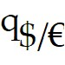
∙ Nominal exchange rate = 
∙ Price of an unchanging basket in US = Pus
∙ Price of an unchanging basket in Europe = PE
Then,
 = ( × PE)/PUS
A rise in the real dollar/euro exchange rate is called a real depreciation of the dollar against the euro, a fall in purchasing power of the dollar.
A fall in the real dollar/euro exchange rate is called a real appreciation of the dollar against the euro, a rise in purchasing power of the dollar.
Difficulty: Difficult
AACSB: Application of knowledge

14) Define the concept of the real exchange rate and explain how it differs from the nominal exchange rate.
Answer: In general, the real exchange rate between two countries' currencies is the price of the second country's commodity basket (in terms of the first country's currency) relative to the price of the first country's commodity basket. For example, in the case of U.S. and Europe, the real dollar/euro exchange rate is the dollar value of Europe's price level divided by the U.S. price level. We can thus denote the real dollar/euro exchange rate (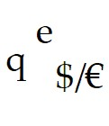) as:
 = ( × PE)/PUS
where  is the nominal dollar/euro exchange rate, PE is Europe's price level, and PUS is the U.S. price level. Unlike the real exchange rate, which is the relative price of two output baskets, the nominal exchange rate is the relative price of two currencies. However, as we can see from the equation above, real exchange rates are defined in terms of nominal exchange rates.
Difficulty: Difficult
AACSB: Application of knowledge

15) Describe the chain of events leading to exchange rate determination for the following cases:
(a) An increase in U.S. money supply
(d) Increase in growth rate of U.S. money supply
(c) Increase in world relative demand for U.S. products
(d) Increase in relative U.S. output supply
Answer: Chain of events leading to exchange rate determination:
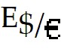 = 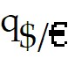 × (Pus/PE)
Increase in U.S. money supply: Pus rises in proportion to the money supply; q remains the same. All dollar prices will rise (including dollar price of euro).
Increase in growth rate of U.S. money supply: Inflation rate, dollar interest rate, Pus, E, rises in proportion to Pus.
Increase in world relative demand for U.S. products: E falls, and q does as well.
Increase in relative U.S. output supply: Dollar depreciates, lowers relative price of U.S. output, rise in q, effect on E is not clear since q and Pus work in opposite directions.
Difficulty: Difficult
AACSB: Application of knowledge

16) Construct a table that will summarize the effects of money market and output market changes on the long-run nominal dollar/euro exchange rate
Answer:
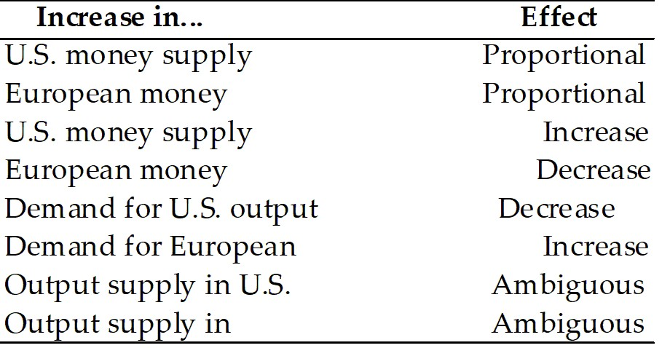

Difficulty: Difficult
AACSB: Application of knowledge

16.7 International Interest Rate Differences and the Real Exchange Rate

1) Interest rate differences between countries depend on
A) differences in expected inflation, but not on expected changes in the real exchange rate.
B) differences in expected changes in the real exchange rate, but not on expected inflation.
C) neither differences in expected inflation, nor on expected changes in the real exchange rate.
D) differences in expected inflation and nothing else.
E) differences in expected inflation, and on expected changes in the real exchange rate.
Answer: E
Difficulty: Easy
AACSB: Application of knowledge

2) The expected rate of change in the nominal dollar/euro exchange rate is best described as
A) the expected rate of change in the real dollar/euro exchange rate minus the U.S.-Europe expected inflation difference.
B) the expected rate of change in the real dollar/euro exchange rate plus the U.S.-Europe real interest rate difference.
C) the expected rate of change in the real dollar/euro exchange rate plus the U.S.-Europe expected inflation difference.
D) the expected rate of change in the real dollar/euro exchange rate minus the U.S.-Europe real interest rate difference.
E) the expected rate of change in the real dollar/euro exchange rate plus the European expected inflation.
Answer: C
Difficulty: Easy
AACSB: Application of knowledge

3) The expected change in the real dollar/euro exchange rate is
A) the expected change in the nominal dollar/euro exchange rate minus the U.S.-Europe expected inflation difference.
B) the expected change in the nominal dollar/euro exchange rate plus the U.S.-Europe expected inflation difference.
C) the expected change in the nominal dollar/euro exchange rate minus the real interest rate difference.
D) the expected change in the nominal dollar/euro exchange rate plus the real interest rate difference.
Answer: A
Difficulty: Easy
AACSB: Application of knowledge

4) If the expected rate of real dollar depreciation against the euro is 1 percent per year, and the expected inflation difference between the United States and Europe is 5 percent per year, the dollar/euro interest difference will be ________ percent.
A) 6
B) 4
C) 3
D) 2
E) 1
Answer: A
Difficulty: Easy
AACSB: Application of knowledge

16.8 Real Interest Parity

1) Nominal interest rates are
A) rates of return measured in monetary terms.
B) rates of return measured in terms of a country's output.
C) rates of return measured in PPP terms.
D) rates of return after taking inflation into account.
Answer: A
Difficulty: Easy
AACSB: Application of knowledge

2) Real interest rates are
A) rates of return measured in terms of a country's output.
B) rates of return measured in monetary terms.
C) rates of return measured in PPP terms.
D) rates of return before taking inflation into account.
Answer: A
Difficulty: Easy
AACSB: Application of knowledge

3) The expected real interest rate (re) in terms of the nominal interest rate (R) and the expected inflation rate (πe) is given by
A) re = πe + R.
B) re = 2πe + R2.
C) re = πe + R2.
D) re = R - πe.
E) re = R2 - πe.
Answer: D
Difficulty: Easy
AACSB: Application of knowledge

4) The difference between nominal and real interest rates is that
A) nominal interest rates are measured in terms of a country's output, while real interest rates are measured in monetary terms.
B) nominal interest rates are measured in monetary terms, while real interest rates are measured in terms of a country's output.
C) nominal interest rates can fluctuate, while real interest rates always remain fixed.
D) real interest rates can fluctuate, while nominal interest rates always remain fixed.
E) real interest rates are the same in every country, while nominal interest rates are different for every country.
Answer: B
Difficulty: Easy
AACSB: Application of knowledge

5) What is the real interest rate parity condition?
Answer: Real Interest Parity Condition: (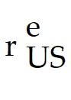 - 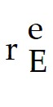) = (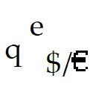 -  )/
Difficulty: Moderate
AACSB: Application of knowledge

6) Is a depreciation of the dollar/euro exchange rate correlated with a decrease in the dollar return on U.S. deposits? Explain your answer.
Answer: No.
Assume that the Interest Parity is maintained, i.e.,
R$ = 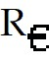 + (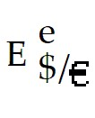 - )/
Holding  constant, one would expect a depreciation of the dollar/euro exchange rate (i.e. increase in 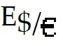) to be correlated with a decrease in R$, dollar returns on euro deposits. However, the higher expected inflation in the U.S. implies an increase in the 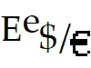, the expected future dollar to euro exchange rate. Thus, the quantity ( - )/ goes up and, increases despite a depreciation in the current dollar to euro exchange rate, .
Difficulty: Difficult
AACSB: Application of knowledge
16.9 Appendix to Chapter 16: The Fisher Effect, the Interest Rate, and the Exchange Rate Under the Flexible-Price Monetary Approach

1) The monetary approach to interest rates assumes that the prices of goods are ________, which implies that a country's currency will ________, when nominal interest rates ________ because of ________ expected future inflation.
A) perfectly flexible; depreciate; increase; higher
B) perfectly flexible; appreciate; increase; higher
C) immutable; depreciate; increase; higher
D) immutable; appreciate; decrease; higher
E) absolutely inflexible; depreciate; decrease; higher
Answer: A
Difficulty: Moderate
AACSB: Application of knowledge

2) When the nominal dollar interest rate ________, money demand will ________, and the general price level will ________.
A) increases; decrease; increase
B) increases; increase; increase
C) increases; decrease; decrease
D) increases; increase; decrease
E) decreases; increase; increase
Answer: A
Difficulty: Easy
AACSB: Application of knowledge

3) To answer the following question, please refer to the figure below. Concentrating only at the lower right quadrant, discuss the effects of a change in U.S. expected inflation.

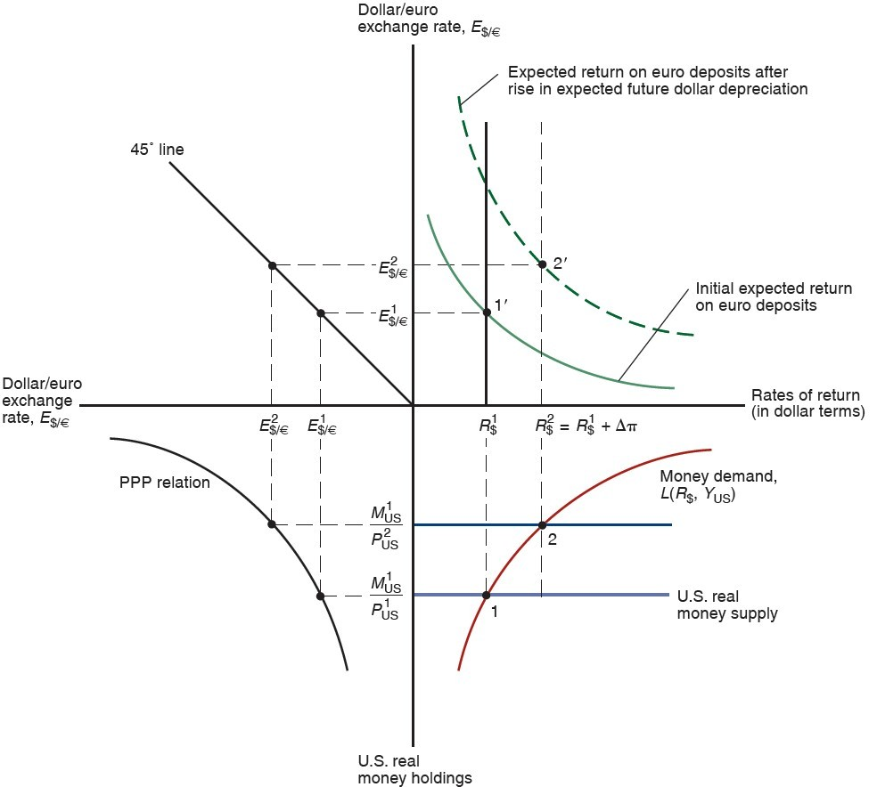

Answer: The lower right quadrant shows the equilibrium in the U.S. Money Market, where
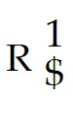 = 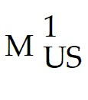/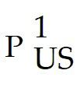
A given interest rate  corresponds with a given U.S. real money supply, /.
Consider a rise of ΔΠ in the future rate of U.S money supply growth (i.e. an increase in the expected rate of inflation).
The Key point: The rise in expected future inflation generates expectations of more rapid currency depreciation in the future.
Under PPP the dollar now depreciates at a rate of Π+ΔΠ. Interest parity therefore requires the dollar interest rate to rise where
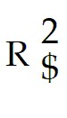 =  + ΔΠ (Point 2 in the figure.)
Note: R$ -  =  - 

This relation shows a change in the U.S. interest rate due to an increase in expected U.S. inflation has no effect on the euro interest rate.

The rise in the interest rate from  to  creates a monetary excess supply of real U.S. money balances at the prevailing price level P1. However, since under this Monetary Approach, prices are assumed to be flexible, prices will immediately adjust from P1 to P2, thus causing the following two effects: One, reducing real money supply and two, bringing U.S. money market back into equilibrium.
Difficulty: Difficult
AACSB: Application of knowledge

4) To answer the following question, please refer to the figure below. Concentrating only at the lower left quadrant, discuss the relationship between the U.S. real money supply and the dollar/euro exchange rate, E$/E.


Answer: The lower left quadrant in the figure described the Purchasing Power Parity (PPP) relationship. The relationship between the U.S. real money supply and the dollar/euro exchange rate, E$/E is negative.
 is equal to the price level ratio, PUS/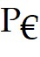.
In this derivation of the relationship, the following variables are assumed constants: , , and .
So,  = /PUS
PUS ↑ →  ↑
 → 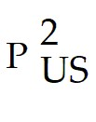
Thus, the purchasing power of the dollar decreases due to the increase in the price level.
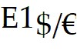 → 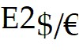
i.e., dollar depreciates due to PPP
Difficulty: Difficult
AACSB: Application of knowledge

5) To answer the following question, please refer to the figure below. Concentrating only at the upper right quadrant, discuss the foreign exchange market equilibrium.

Answer: The upper right quadrant describes the equilibrium in the foreign exchange market.
We begin with the Interest Parity Condition.
R$ =  + ( - )/
In general, two effects are present:
 →  and 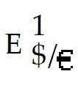 → 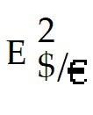
A rise in the interest rate normally creates an excess demand for dollar deposits and appreciation in the currency market.
However, in this case the increase is due to higher expected inflation or higher expected monetary growth in the U.S. which implies a faster expected depreciation of the dollar against the euro, , thus,  goes up and thus reduced the attractiveness of U.S. deposits.
Difficulty: Difficult
AACSB: Application of knowledge

